QUSTION1 -What is the major reason people being kidnapped in each and every state?

SOLUTION –

SQL QUERY-

SELECT "innertab".field1 as area_name,"innertab".Group_Name,max(innertab."total cases") as total_case

FROM

(SELECT field1,Group_Name,SUM("K_A_Cases_Reported") as "total cases"

FROM "aaaa"

GROUP BY field1,Group_Name)innertab

group by field1

ORDER by max(innertab."total cases") DESC

RESULT OF QUERY:-

Follow this link for result of this query:

https://docs.google.com/spreadsheets/d/1AVy-lIBFoCh0lKcxagKdFLnN8DCaP4d0z6RubwOu5Ag/edit?usp=sharing

Visualization:

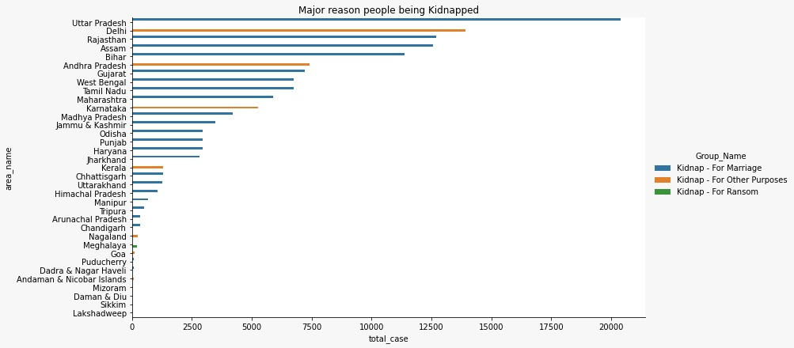

Conclusion:

1.We can see by this graph ,highest numbers case of kidnapping in Uttar Pradesh.

2.And the reason of kidnapping is marriage.

3.lowest kidnapping in Lakshadweep.

Qustion2-Offenders relation to the rape victim?

SOLUTION-

SQL QUERY-

SELECT Area_Name,SUM("No_of_Cases_in_which_offenders_were_Relatives"),sum("No_of_Cases_in_which_offenders_were_Parentsclose_family_members")as "offenders were relative"

FROM "21_Offenders_known_to_the_victim"

GROUP BY Area_Name

ORDER by "offenders were relative" DESC

RESULT OF QUERY:-

Follow this link for result of this query:

https://docs.google.com/spreadsheets/d/1O8uO5g8mG8SGWn4CKRRnFwlDSt7inh7nA4Fp_KZ3ZW0/edit?usp=sharing

Visualization:

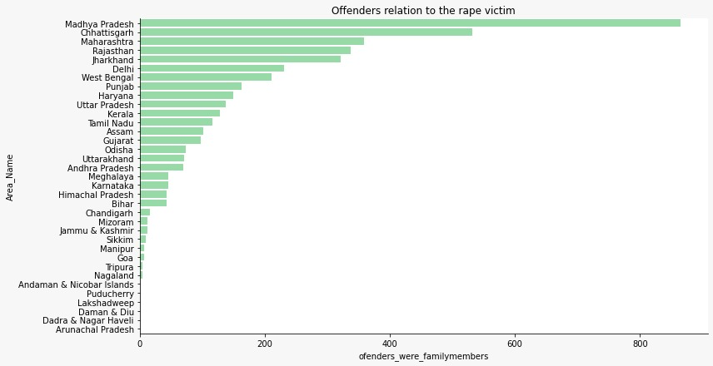

Conclusion:

1. We can see by this graph, most cases where offenders were family member.

2. Highest case where offenders were family member in Madhya Pradesh.

3. Lowest case where offenders were family member in Arunachal Pradesh.

Qustion3- Juveniles family background, education and economic setup.

SOLUTION-

SQL QUERY-

SELECT "Area_Name", sum(RES."total_educated")as total_educated,sum(RES."Education_Illiterate")as Education_Illiterate,sum(RES."Family_back_ground_Homeless")as Family_back_ground_Homeless,sum(RES."living_with_perants_and_gardian")as living_with_perants_and_gardian,sum(RES."Economic_Set_up_Total") as Economic_Set_up_Total

FROM

(SELECT tabelone."Area_Name",tabelone."total_educated",tabelone."Education_Illiterate",tabeltwo."Family_back_ground_Homeless",tabeltwo."living_with_perants_and_gardian",tabelthree."Economic_Set_up_Total"

FROM tabelone

INNER JOIN tabeltwo ON tabelone."Area_Name"=tabeltwo."Area_Name"

INNER JOIN tabelthree on tabeltwo."Area_Name"=tabelthree."Area_Name")RES

GROUP by "Area_Name"

RESULT OF QUERY:-Follow this link for result of this query:

https://docs.google.com/spreadsheets/d/1Fbi0nfdTc2YdUpqd7ysMqxFriPCOx9MB64i3iOsTdU0/edit?usp=sharing

Visualization:

GROUP-1

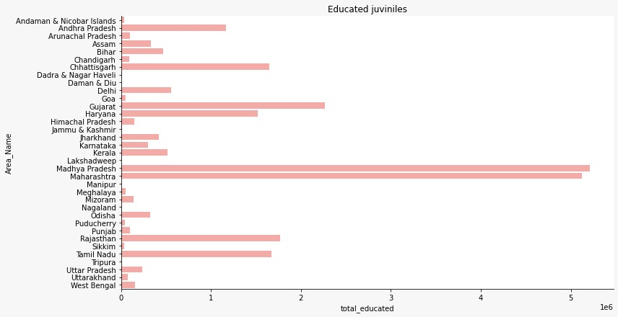

1. By this graph we can see highest educated juveniles in Madhya Pradesh .

Graph-2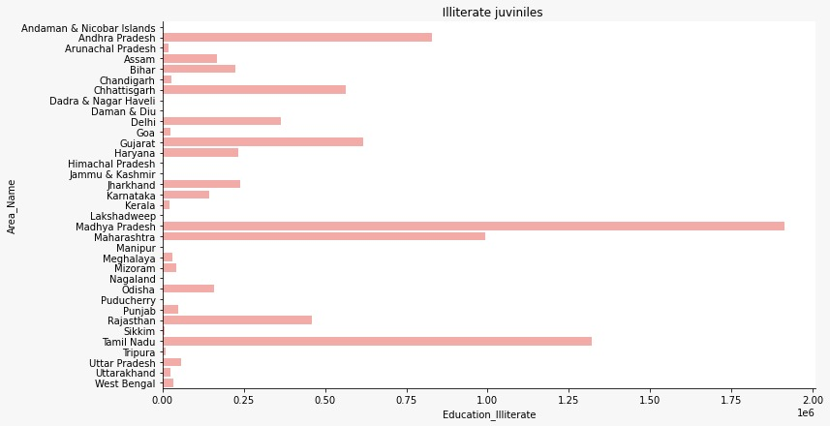

1. 1.By this graph we can see highest illiterate juveniles in Madhya Pradesh ..

Graph-3

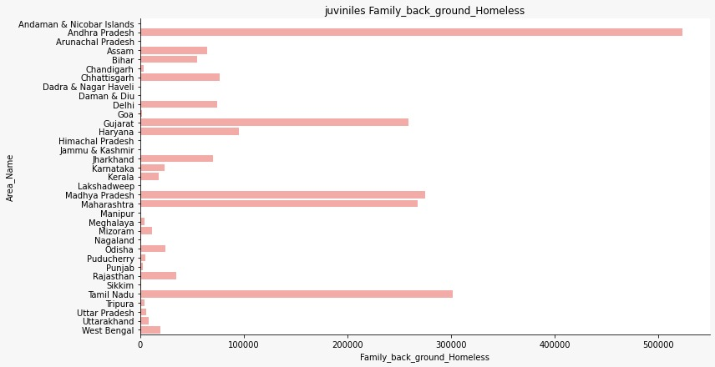

1. By this graph we can see highest homeless juveniles in Andhra Pradesh.

Graph-4:

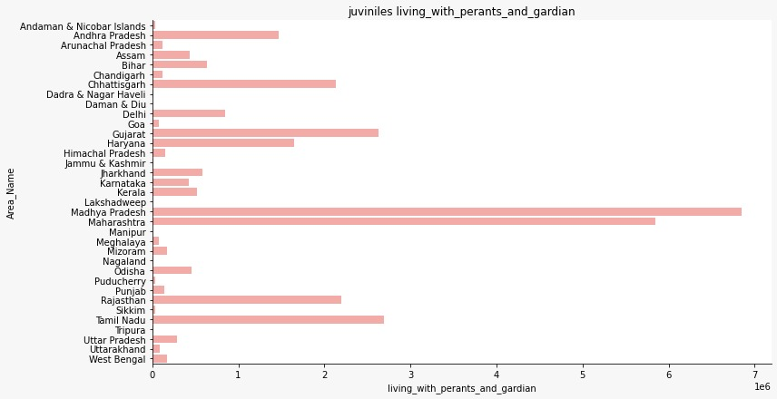

1. By this graph we can see highest juveniles living with parents and guardians in Madhya Pradesh.

Graph-5

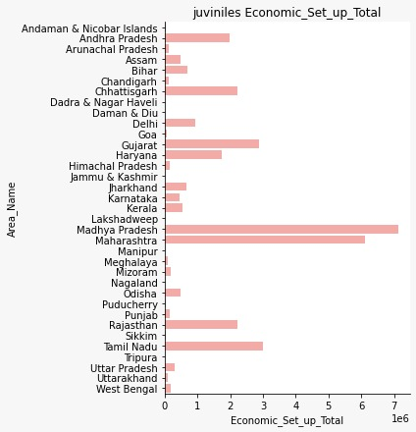

1. Highestjuvenile’s economic setup in Madhya Pradesh.

Qustion4-Which state has more crime against children and women?

SOLUTION-

SQL QUERY-

SELECT "STATE/UT", sum(RES."total")as child_case,sum(RES.total_cases)as women_case

FROM

(SELECT tabelone."STATE/UT",tabelone."total",tabeltwo."total_cases"

FROM tabelone

INNER JOIN tabeltwo ON tabelone."STATE/UT"=tabeltwo."STATE/UT")RES

GROUP by "STATE/UT"

ORDER by "total","total_cases" DESC

RESULT OF QUERY:-

Follow this link for result of this query:

https://docs.google.com/spreadsheets/d/1TmR_mQ-ym0R7Or94tV5LSu09SKjKwsdL15ohI7eD650/edit?usp=sharing

Visualization:

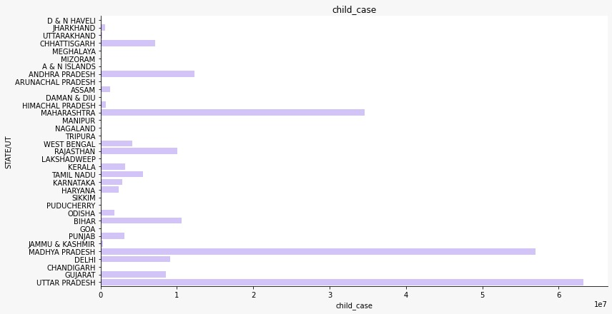

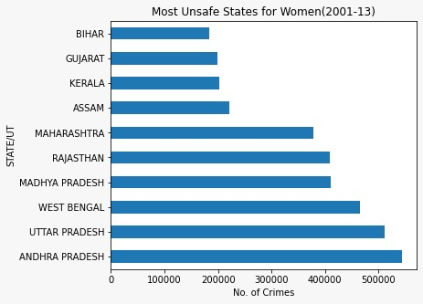

Conclusion:

1. According to above graph Uttar Pradesh have highest case against children.

2. and Andhra Pradesh have highest case against women.

Qustion5-Age group wise murder victim?

SOLUTION-

SQL QUERY-

SELECT "Area_Name", sum("Victims_Above_50_Yrs")as age_group_50yr,sum("Victims_Upto_10_15_Yrs") as age_group_10_15yr,sum("Victims_Upto_15_18_Yrs") as age_group_15_18yr,

sum("Victims_Upto_30_50_Yrs")as age_group_30_50yrs

FROM tabelone

Group by Area_Name;

RESULT OF QUERY:-

Follow this link for result of this query:

https://docs.google.com/spreadsheets/d/15wV3ZsDoKpkSJWB9RBz7G_pn7uG05QhHwe3cFO50BoA/edit?usp=sharing

Visualization:

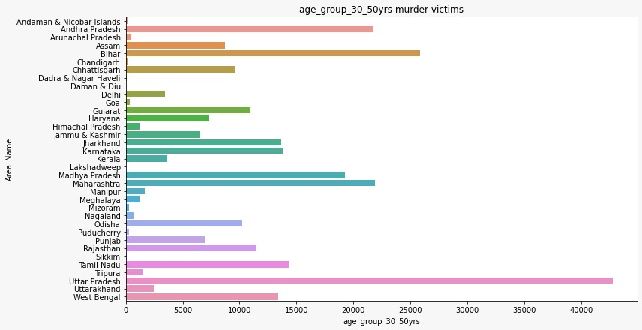

Conclusion:

1. According to above question highest murder victim are inage between 30 - 50.
2. So by this graph we can see highest murder victim of age 30- 50 are in Uttar Pradesh.

Qustion6-Crime by place of occurrence.

SOLUTION-

SQL QUERY-

SELECT "STATE/UT","PlaceOfOccurrence",sum("Dacoity(Section395-398IPC)-Numberofcasesregistered")as Dacoity,sum("Robbery(Section392-394397398IPC)-Numberofcasesregistered")as Robbery,sum("Burglary(Section449-452454455457-460IPC)-Numberofcasesregistered")as Burglary,sum("Theft(Section379-382IPC)-Numberofcasesregistered") as Theft

FROM quetion6

GROUP by "STATE/UT","PlaceOfOccurrence"

RESULT OF QUERY:-

Follow this link for result of this query:

https://docs.google.com/spreadsheets/d/1cBRPT6e5rUETOmOT0RIY4lXQPeOIyAwplaP8tXCfb40/edit?usp=sharing

Visualization:

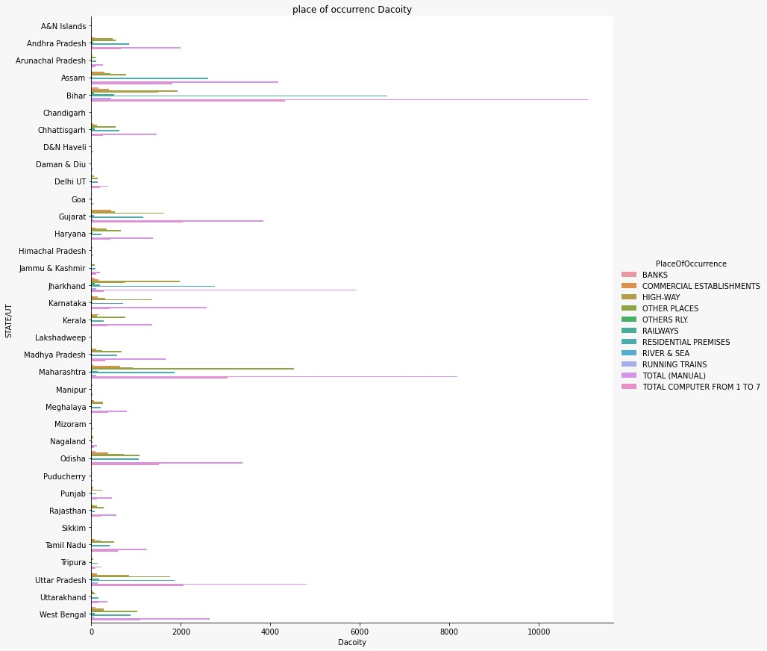

Conclusion:

1. According to this graph we see highest crime of place are banks.
2. and highest crime of place are banks in Bihar.

Qustion7- Anti corruption cases vs arrests.

SOLUTION-

SQL QUERY-

SELECT "Area_Name", sum(rest.AC03_Total_No_of_cases_for_investigation_during_the_year),sum(rest."ACA02_No_of_persons_arrested_during_the_year")

FROM

(SELECT "23_Anti_corruprion_cases"."area_name","23_Anti_corruprion_cases"."AC03_Total_No_of_cases_for_investigation_during_the_year","24_Anti_corruption_arrests"."ACA02_No_of_persons_arrested_during_the_year"

FROM "23_Anti_corruprion_cases"

INNER JOIN "24_Anti_corruption_arrests" ON "23_Anti_corruprion_cases".Area_name="24_Anti_corruption_arrests".Area_name)rest

group by Area_Name

ORDER by "AC03_Total_No_of_cases_for_investigation_during_the_year" ,"ACA02_No_of_persons_arrested_during_the_year" ASC

RESULT OF QUERY:-

Follow this link for result of this query:

https://docs.google.com/spreadsheets/d/1lfhm4qOPiZNX4zVwvL1WuOPZ6L_RqUCk0nbeYPypCaY/edit?usp=sharing

Visualization:

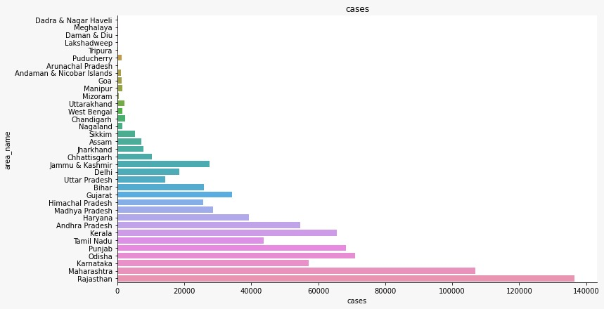

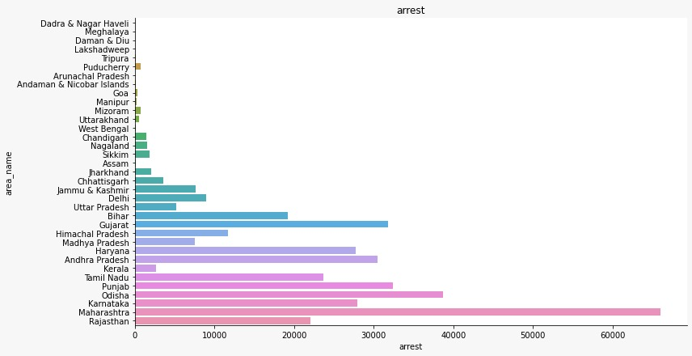

Conclusion:

1. According to above graphs highest cases registered in Rajasthan.

2. And highest arrest in Maharashtra

.Qustion8-Which state has more number of complaints against police?

SOLUTION-

SQL QUERY-

SELECT Area_Name,SUM("CPA_-_Cases_Registered")as total_case

FROM quetion_number8

GROUP BY Area_Name

ORDER by total_casedesc

RESULT OF QUERY:-

Follow this link for result of this query:

https://docs.google.com/spreadsheets/d/1uSSl73Hf1wpll_DWXfqkWGWj7YW_lzS77Diki-gQrpc/edit?usp=sharing

Visualization:

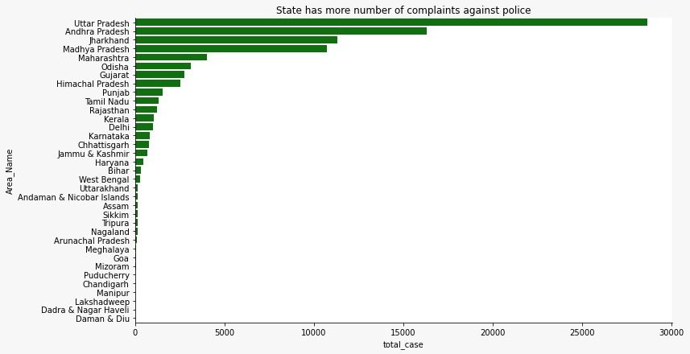

Conclusion:

1. We can see by this graph highest case against police is registered in Uttar Pradesh.

Qustion9-Which state is the safest for foreigners?

SOLUTION-

SQL QUERY-

SELECT "STATE/UT", sum(TOTALIPCCRIMES)as Total_ipc_Crime

FROM "01_District_wise_crimes_committed_IPC_2001_2012"

GROUP by "STATE/UT"

ORDER by TOTAL_ipc_Crime ASC

RESULT OF QUERY:-

Follow this link for result of this query:

https://docs.google.com/spreadsheets/d/1DBHx6unvwcwR3ri7RZ5w-wSfsFT05cmSRt9zgkcSHqw/edit?usp=sharing

Visualization:

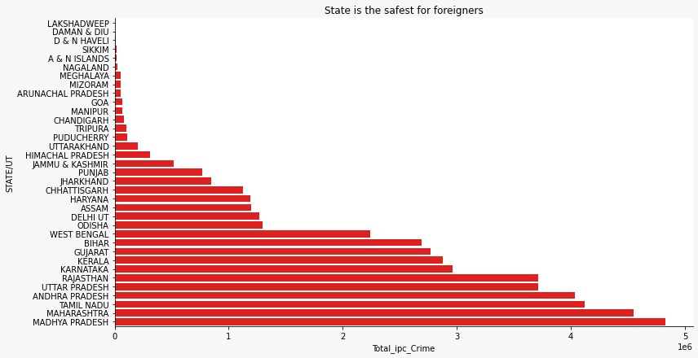

Conclusion:

1. According to IPC crime record Madhya Pradesh has highest case record and Lakshadweep is lowest .
2. So Lakshadweep is safest for foreigners.

Tools and library used in this project:

1. For sql ,DB browser
2. For table, excel
3. For visualization: Pandas , matplotlib, seaborn.

Group members:

1. Devesh chouksey.

2. kishansinghsikarwar.

3. satishchaudary.



qustion 1 -

minor girl also kidnapped for merrige in all the state except lakshdeep .

2. male also kidnapped for merrige and Bihar has highest kidnap male for merriage .

QUSTION4 -

1.most of the crime against women is for dowry and uttarpradesh highest case .

2. most of the importation of girl cases occured in border states (bihar,jharkhand ,westbangale,karnataka)

3.selling of girl child also highest in border state .highest in west bangle